### ASSIGNMENT 3

**NAME:** SREEMATHI SIVAKUMAR **REGISTRATION NO:** 20BEC1174 **DATE:** 06/06/2023

**Sending Commands to WOKWI through Node-Red Dashboard using IBM Watson IoT**

**Aim:** To construct a circuit with DHT11 Temperature Sensor and LED using ESP32 board in WOKWI and send commands to the circuit to switch on and off the LED.

**Software required:** WOKWI , IBM WATSON IoT, Node Red, Node Red Dashboard

**Components Required:** ESP32, 1K Resistor, Push button, Connecting wires

## Circuit Diagram:

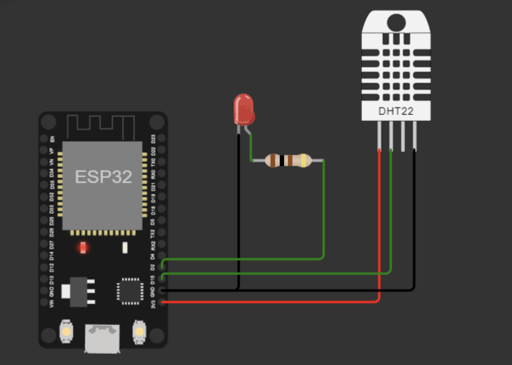

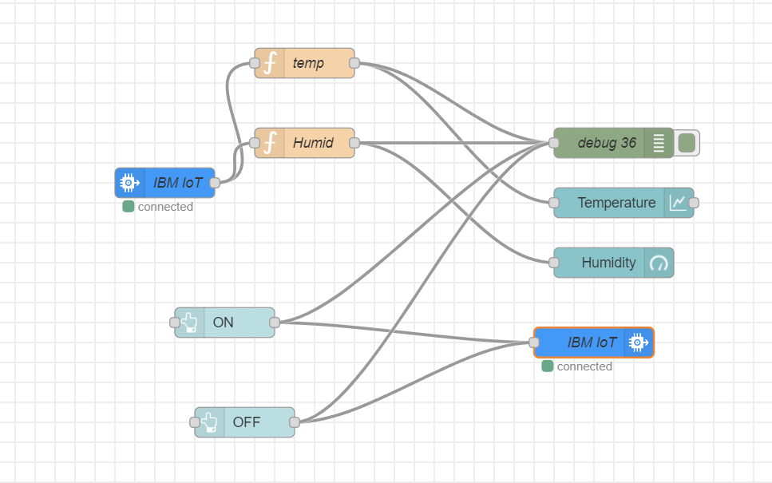**Flow:**

**Simulation:**

**WOKWI:**

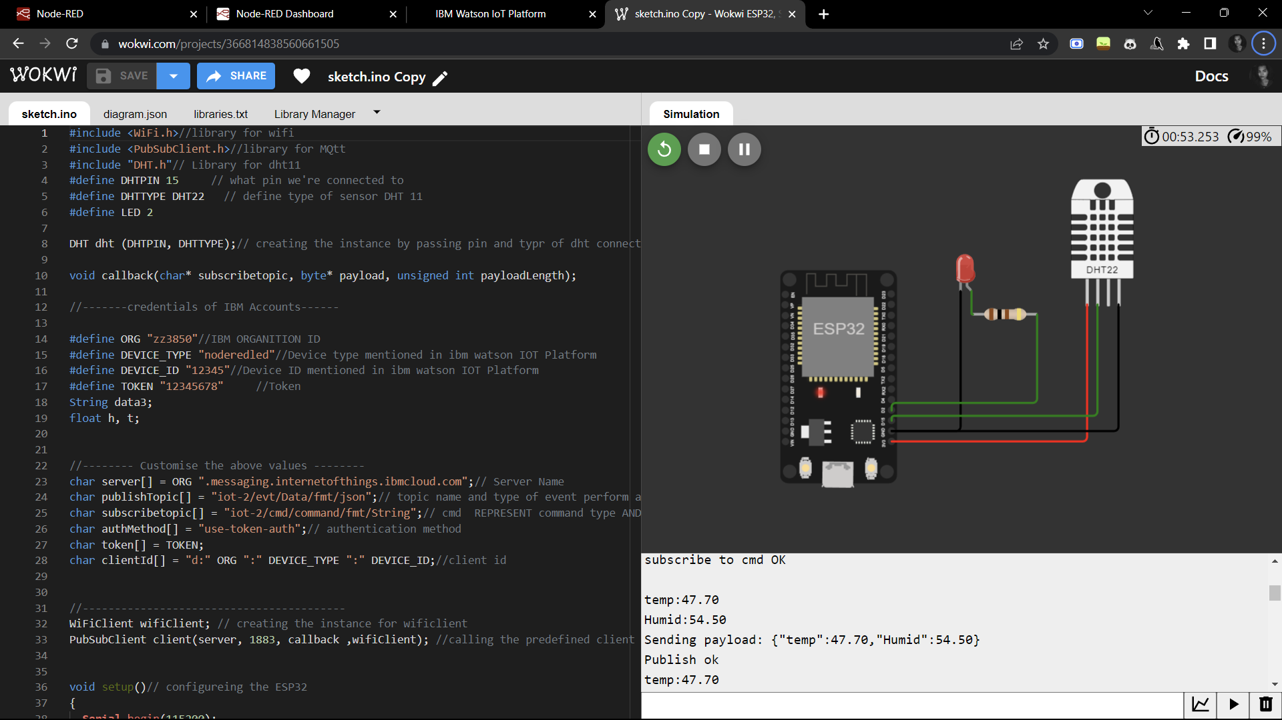

**Code :**

#include <WiFi.h>//library for wifi

#include <PubSubClient.h>//library for MQtt

#include "DHT.h"// Library for dht11

#define DHTPIN 15     // what pin we're connected to

#define DHTTYPE DHT22   // define type of sensor DHT 11

#define LED 2

DHT dht (DHTPIN, DHTTYPE);// creating the instance by passing pin and typr of dht connected

void callback(char* subscribetopic, byte* payload, unsigned int payloadLength);

//-------credentials of IBM Accounts------

#define ORG "zz3850"//IBM ORGANITION ID

#define DEVICE_TYPE "noderedled"//Device type mentioned in ibm watson IOT Platform

#define DEVICE_ID "12345"//Device ID mentioned in ibm watson IOT Platform

#define TOKEN "12345678"     //Token

String data3;

float h, t;

//-------- Customise the above values --------

char server[] = ORG ".messaging.internetofthings.ibmcloud.com";// Server Name

char publishTopic[] = "iot-2/evt/Data/fmt/json";// topic name and type of event perform and format in which data to be send

char subscribetopic[] = "iot-2/cmd/command/fmt/String";// cmd  REPRESENT command type AND COMMAND IS TEST OF FORMAT STRING

char authMethod[] = "use-token-auth";// authentication method

char token[] = TOKEN;

char clientId[] = "d:" ORG ":" DEVICE_TYPE ":" DEVICE_ID;//client id

//-----------------------------------------

WiFiClient wifiClient; // creating the instance for wificlient

PubSubClient client(server, 1883, callback ,wifiClient); //calling the predefined client id by passing parameter like server id,portand wificredential

void setup()// configureing the ESP32

{

**Serial**.begin(115200);

  dht.begin();

  pinMode(LED,OUTPUT);

  delay(10);

**Serial**.println();

  wificonnect();

  mqttconnect();

}

void loop()// Recursive Function

{

  h = dht.readHumidity();

  t = dht.readTemperature();

**Serial**.print("temp:");

**Serial**.println(t);

**Serial**.print("Humid:");

**Serial**.println(h);

  PublishData(t, h);

  delay(4000);

  if (!client.loop()) {

    mqttconnect();

  }

}

/*.....................................retrieving to Cloud...............................*/

void PublishData(float temp, float humid) {

  mqttconnect();//function call for connecting to ibm

  /*

     creating the String in in form JSon to update the data to ibm cloud

  */

  String payload = "{\"temp\":";

  payload += temp;

  payload += "," "\"Humid\":";

  payload += humid;

  payload += "}";

**Serial**.print("Sending payload: ");

**Serial**.println(payload);

  if (client.publish(publishTopic, (char*) payload.c_str())) {

**Serial**.println("Publish ok");// if it sucessfully upload data on the cloud then it will print publish ok in Serial monitor or else it will print publish failed

  } else {

**Serial**.println("Publish failed");

  }

}

void mqttconnect() {

  if (!client.connected()) {

**Serial**.print("Reconnecting client to ");

**Serial**.println(server);

    while (!!!client.connect(clientId, authMethod, token)) {

**Serial**.print(".");

      delay(500);

    }

     initManagedDevice();

**Serial**.println();

  }

}

void wificonnect() //function defination for wificonnect

{

**Serial**.println();

**Serial**.print("Connecting to ");

  WiFi.begin("Wokwi-GUEST", "", 6);//passing the wifi credentials to establish the connection

  while (WiFi.status() != WL_CONNECTED) {

    delay(500);

**Serial**.print(".");

  }

**Serial**.println("");

**Serial**.println("WiFi connected");

**Serial**.println("IP address: ");

**Serial**.println(WiFi.localIP());

}

void initManagedDevice() {

  if (client.subscribe(subscribetopic)) {

**Serial**.println((subscribetopic));

**Serial**.println("subscribe to cmd OK");

  } else {

**Serial**.println("subscribe to cmd FAILED");

  }

}

void callback(char* subscribetopic, byte* payload, unsigned int payloadLength)

{

**Serial**.print("callback invoked for topic: ");

**Serial**.println(subscribetopic);

  for (int i = 0; i < payloadLength; i++) {

    //Serial.print((char)payload[i]);

    data3 += (char)payload[i];

  }

**Serial**.println("data: "+ data3);

  if(data3=="lighton")

  {

**Serial**.println(data3);

digitalWrite(LED,HIGH);

  }

  else

  {

**Serial**.println(data3);

digitalWrite(LED,LOW);

  }

data3="";

}

**IBM Watson Iot:**

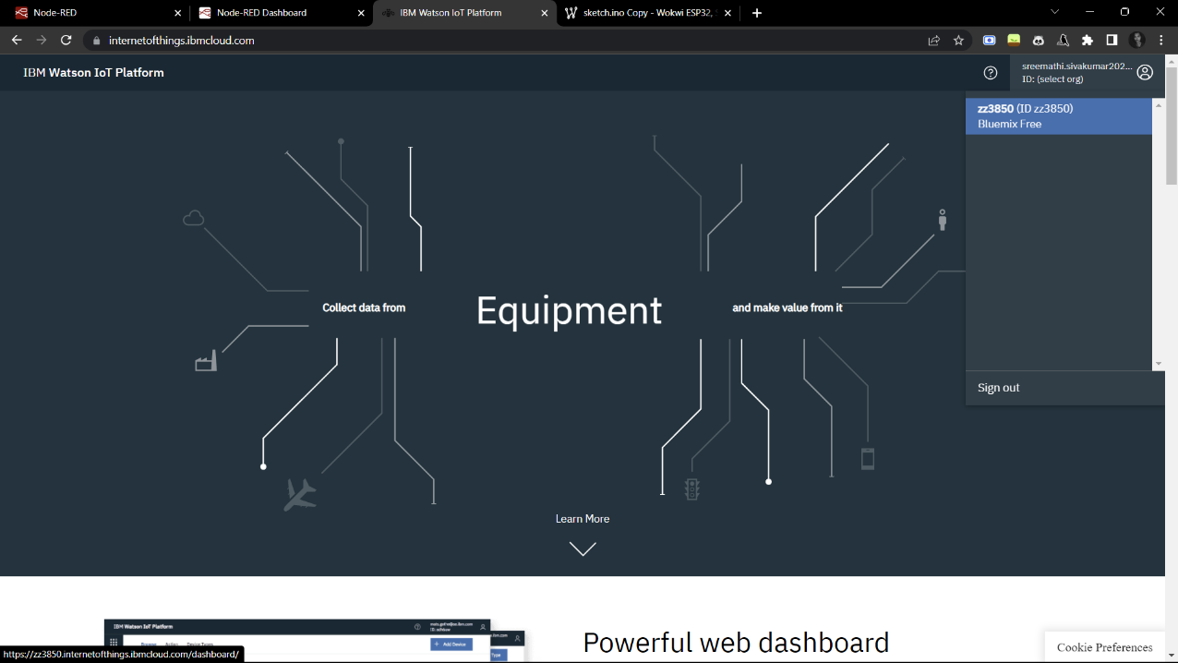

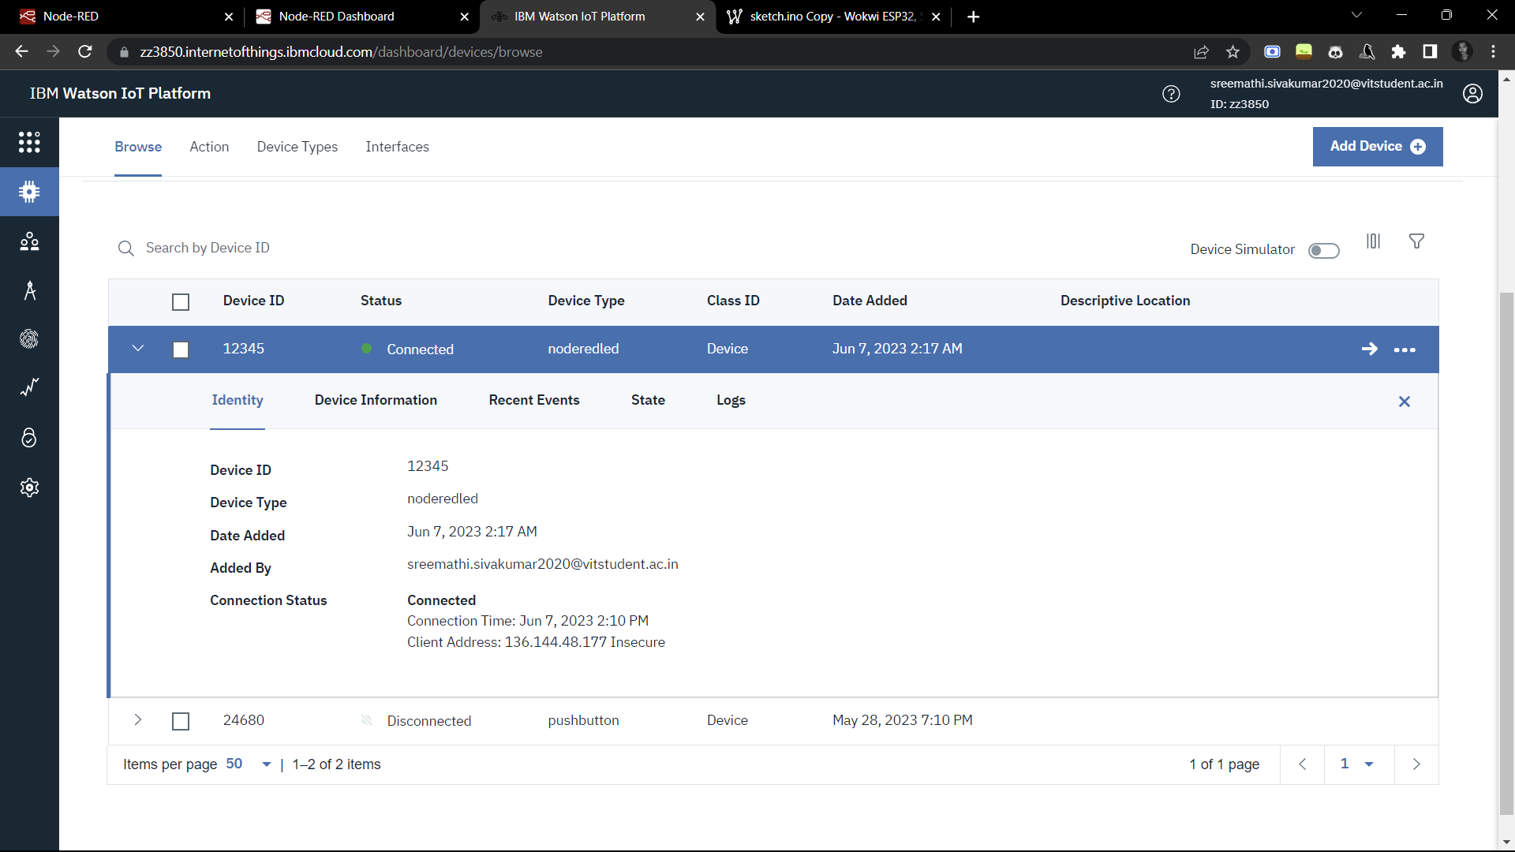

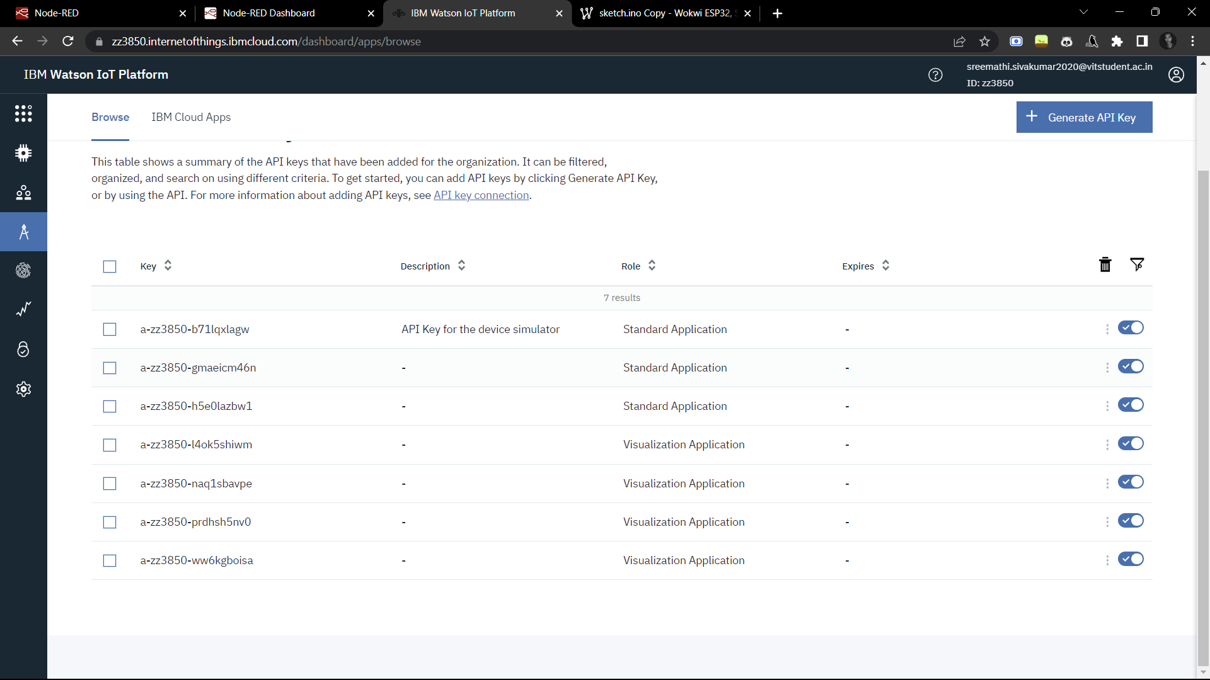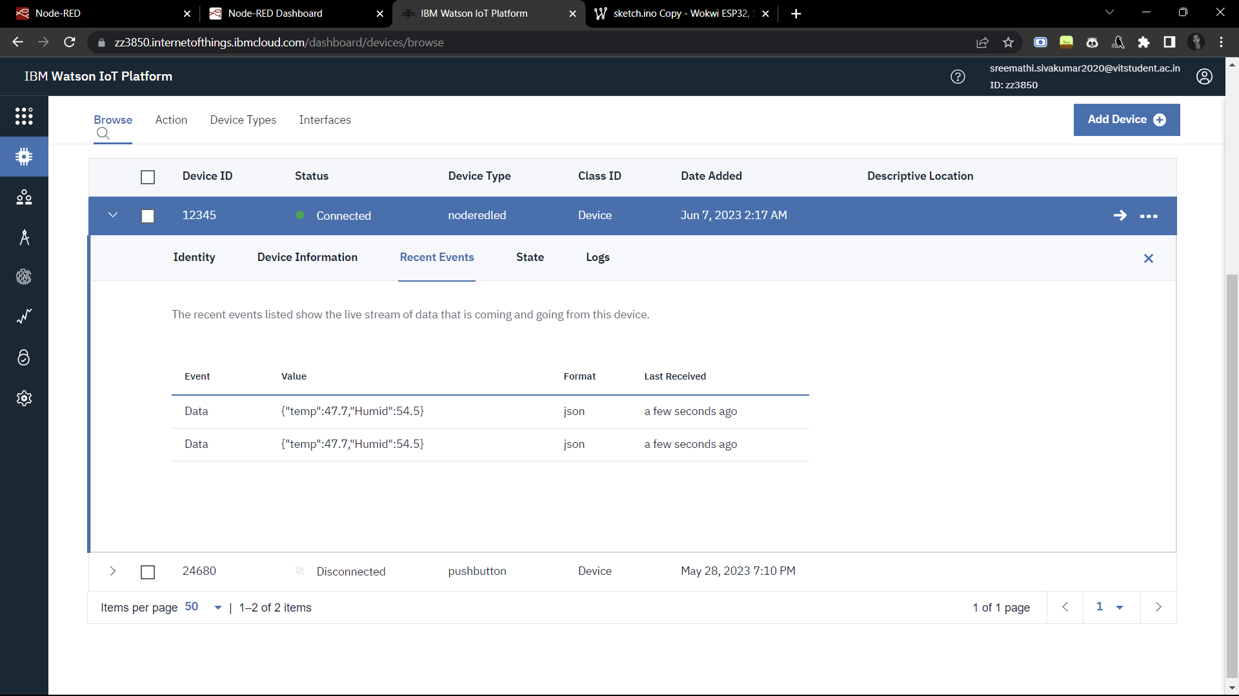

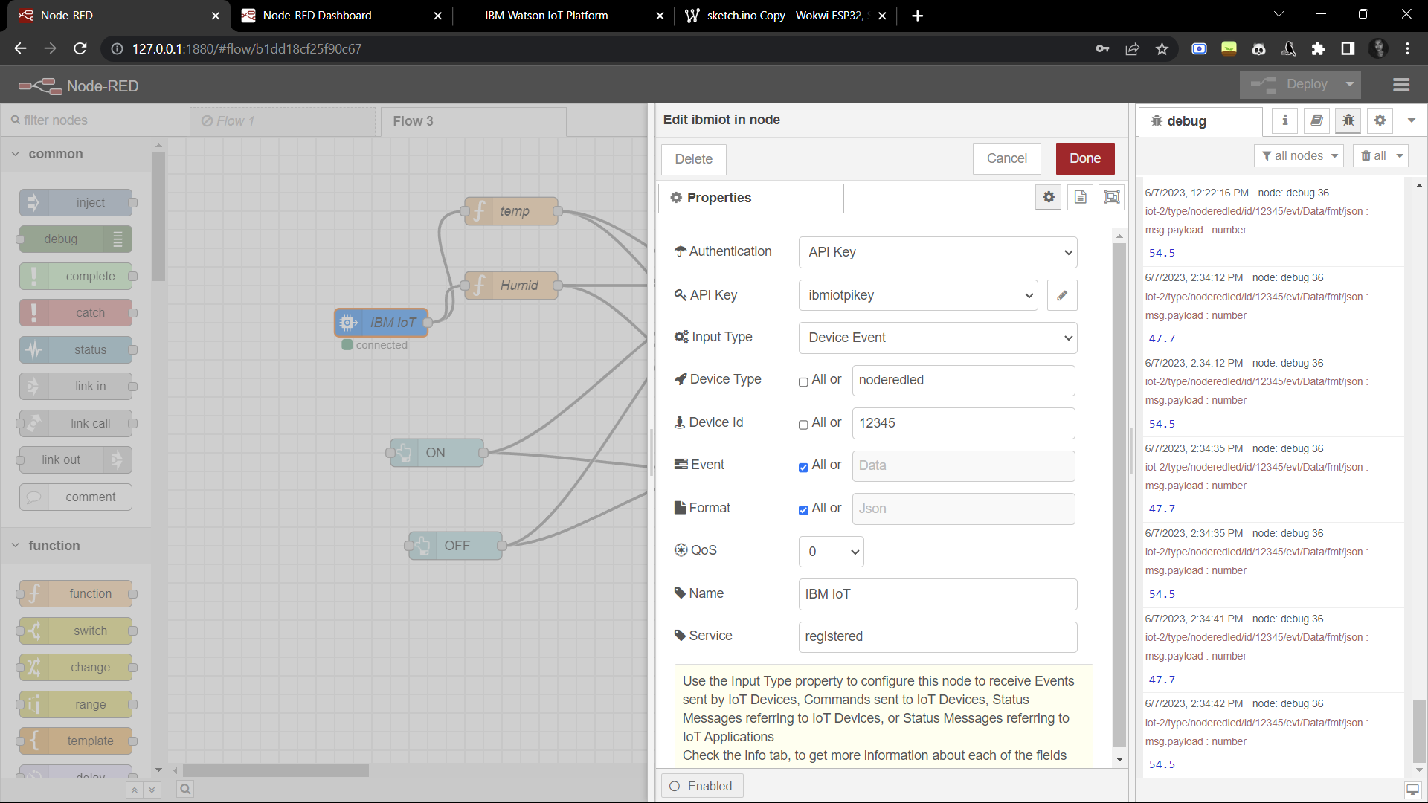**Node Red Nodes:**

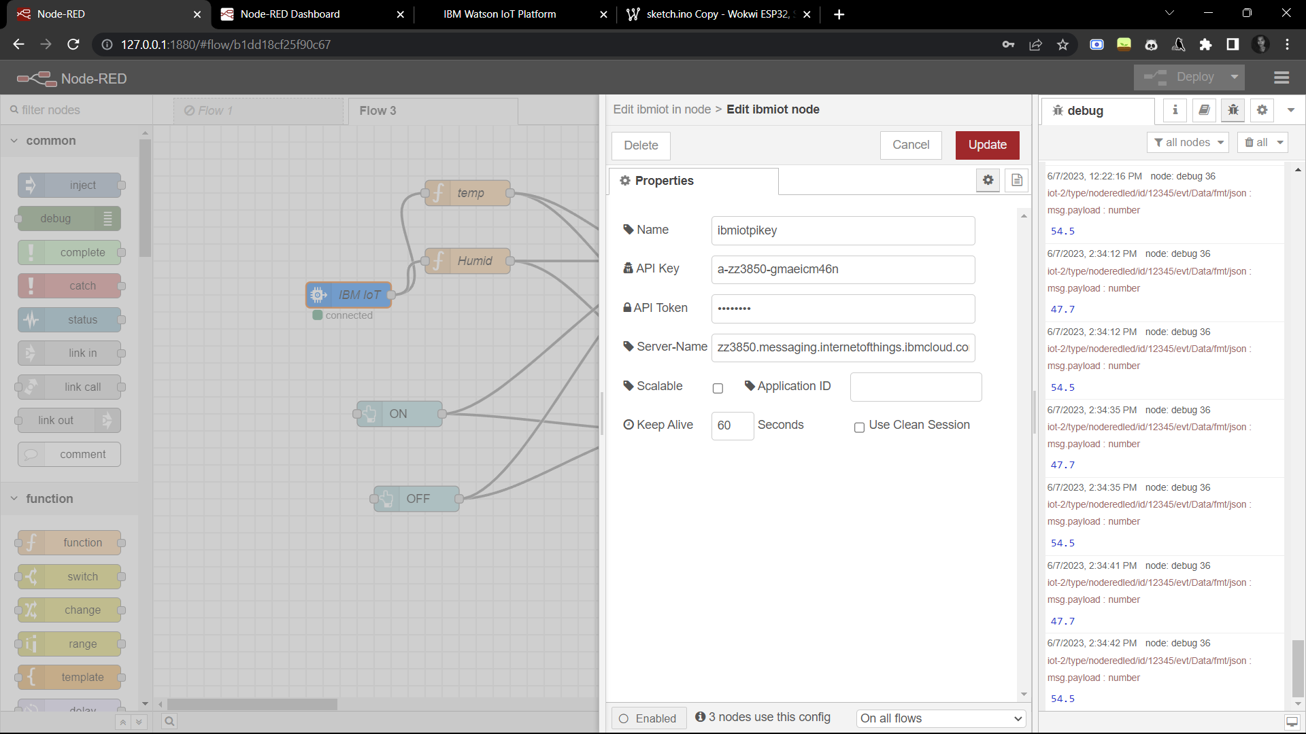

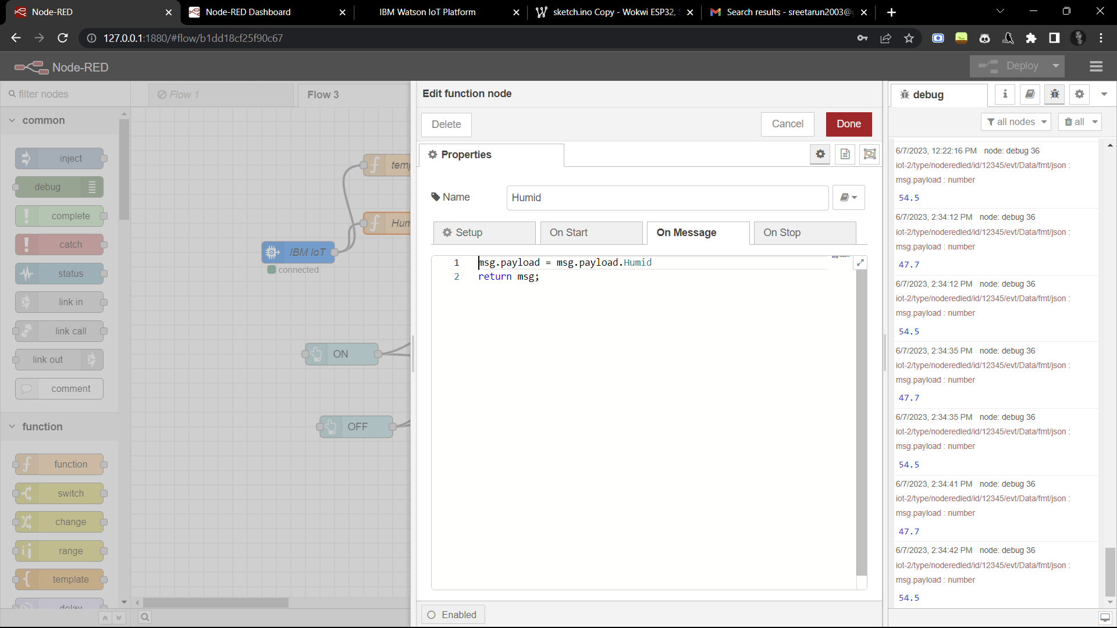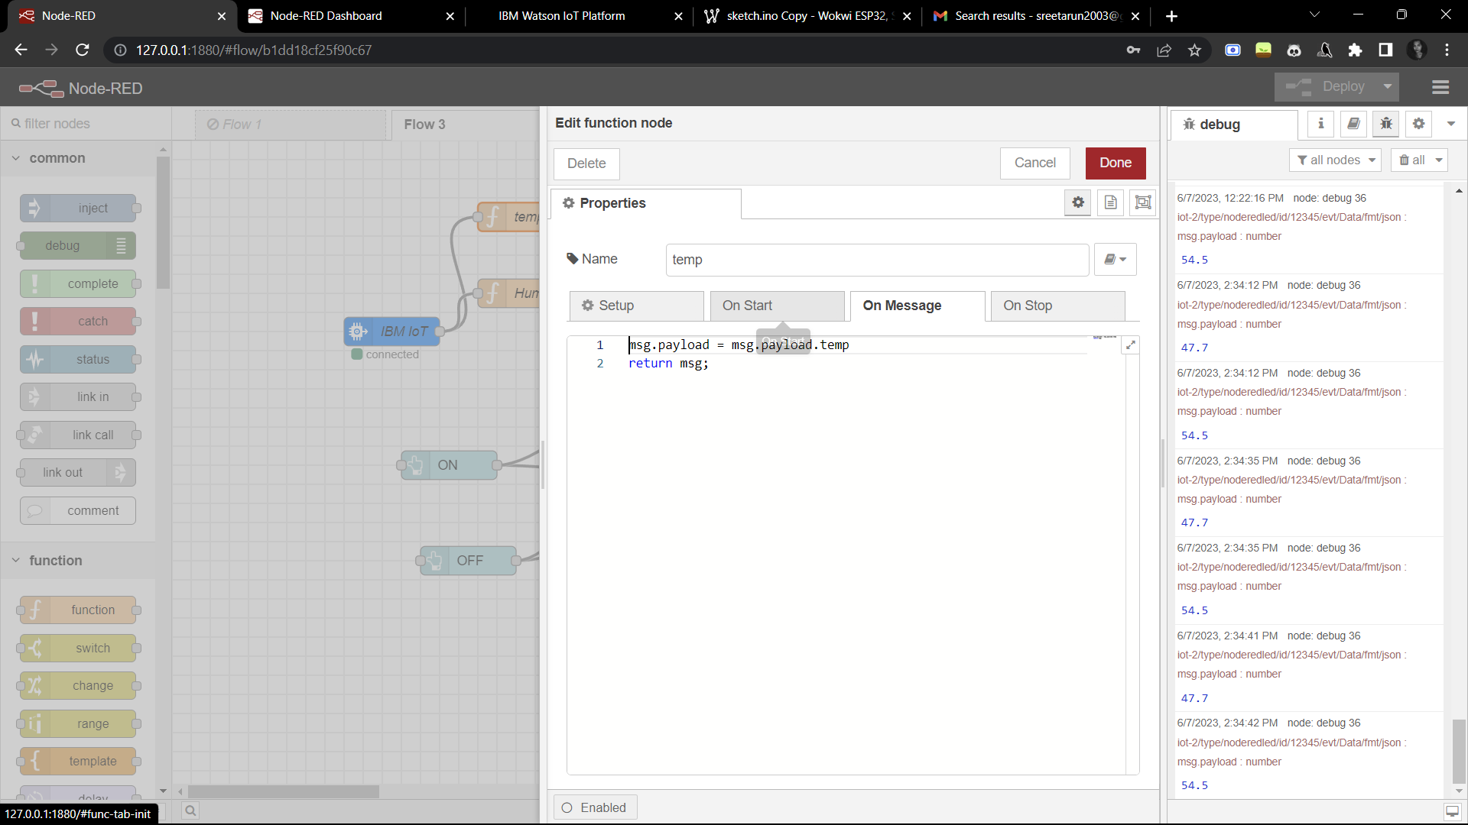

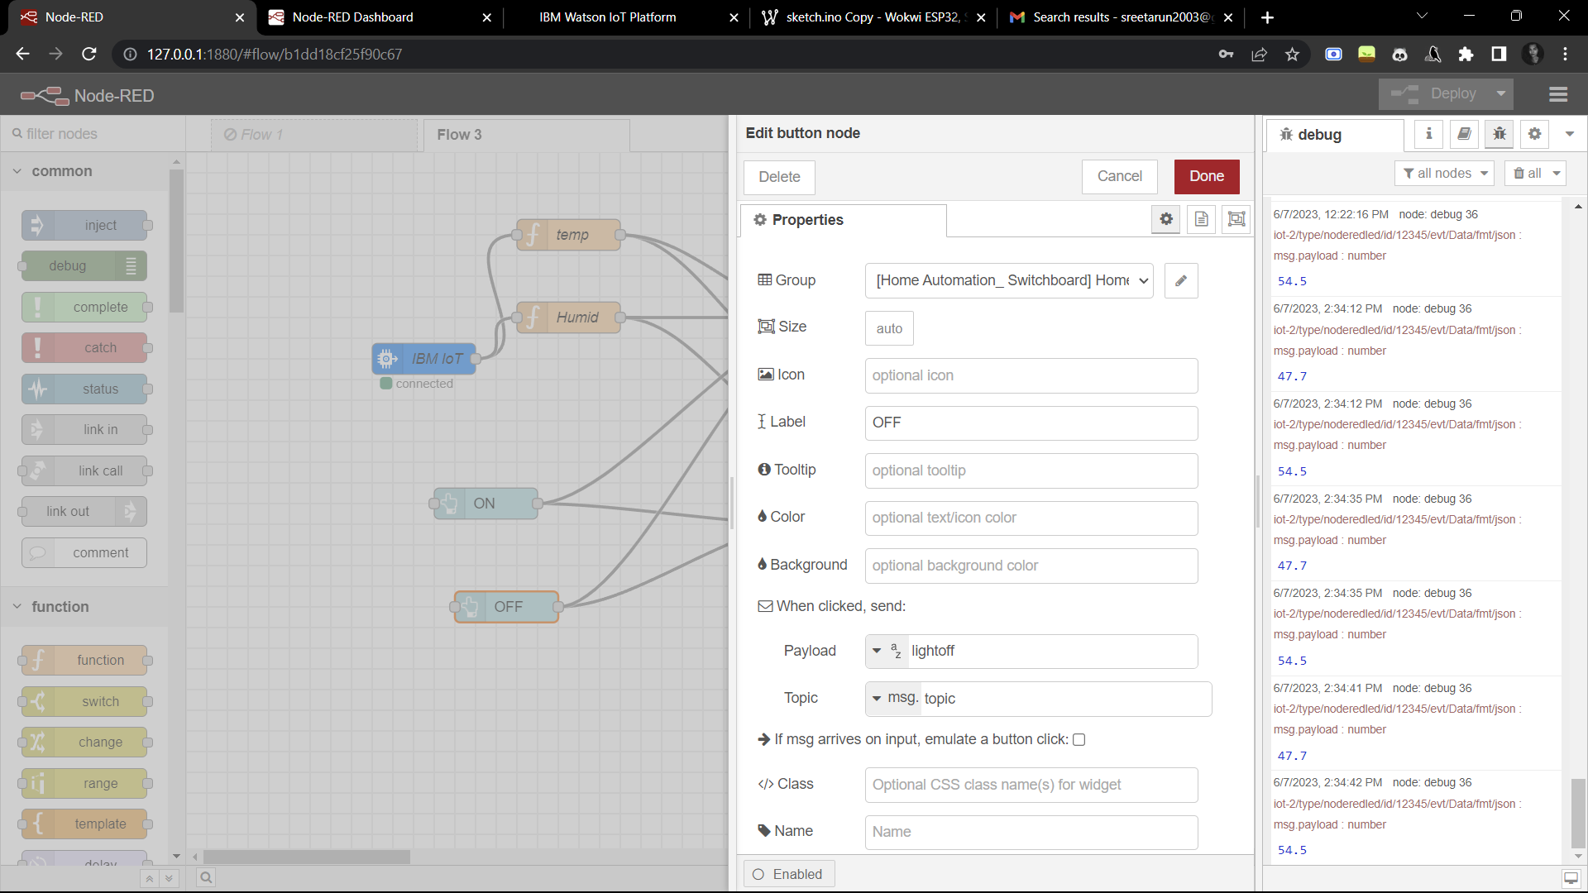

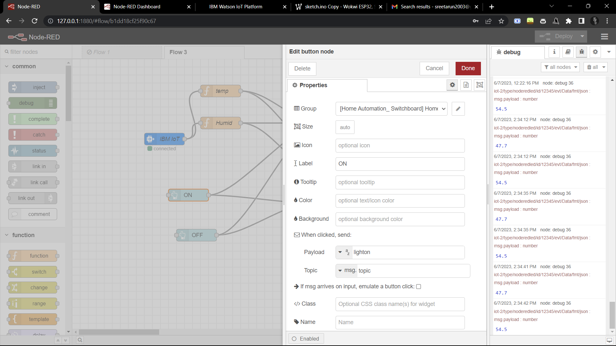

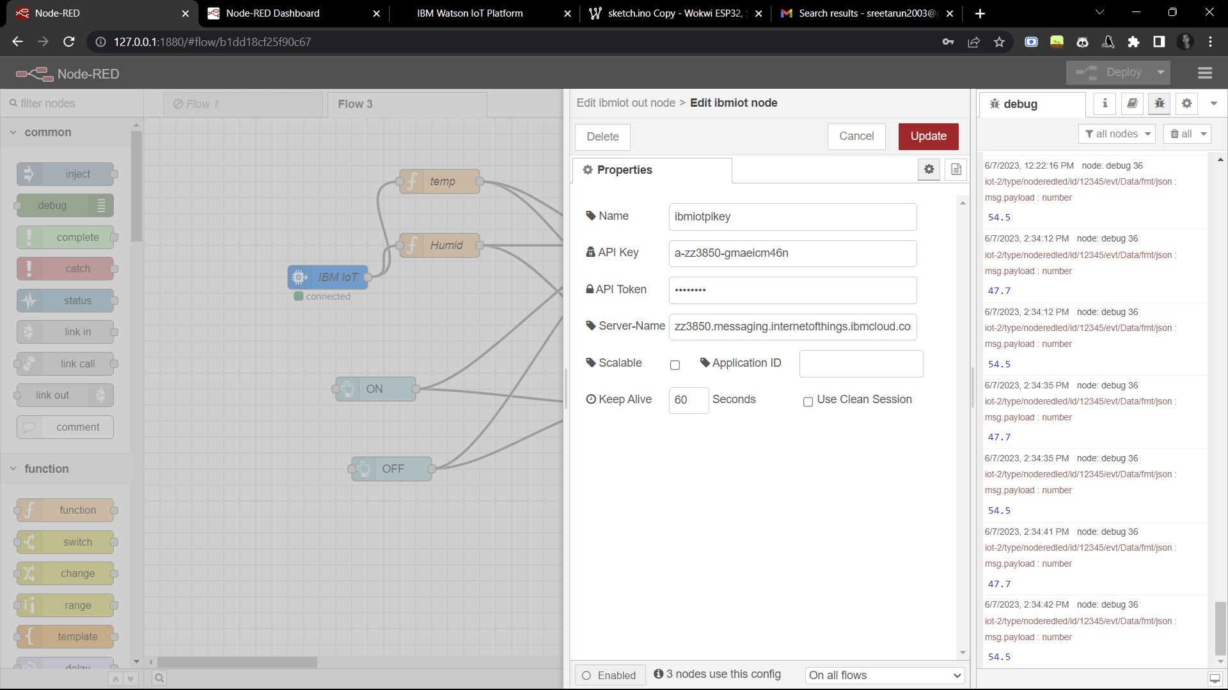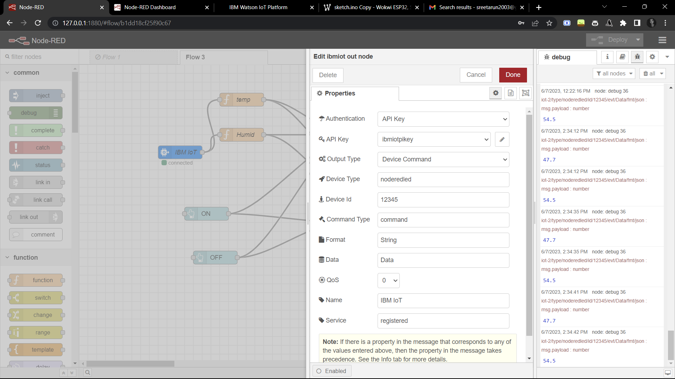

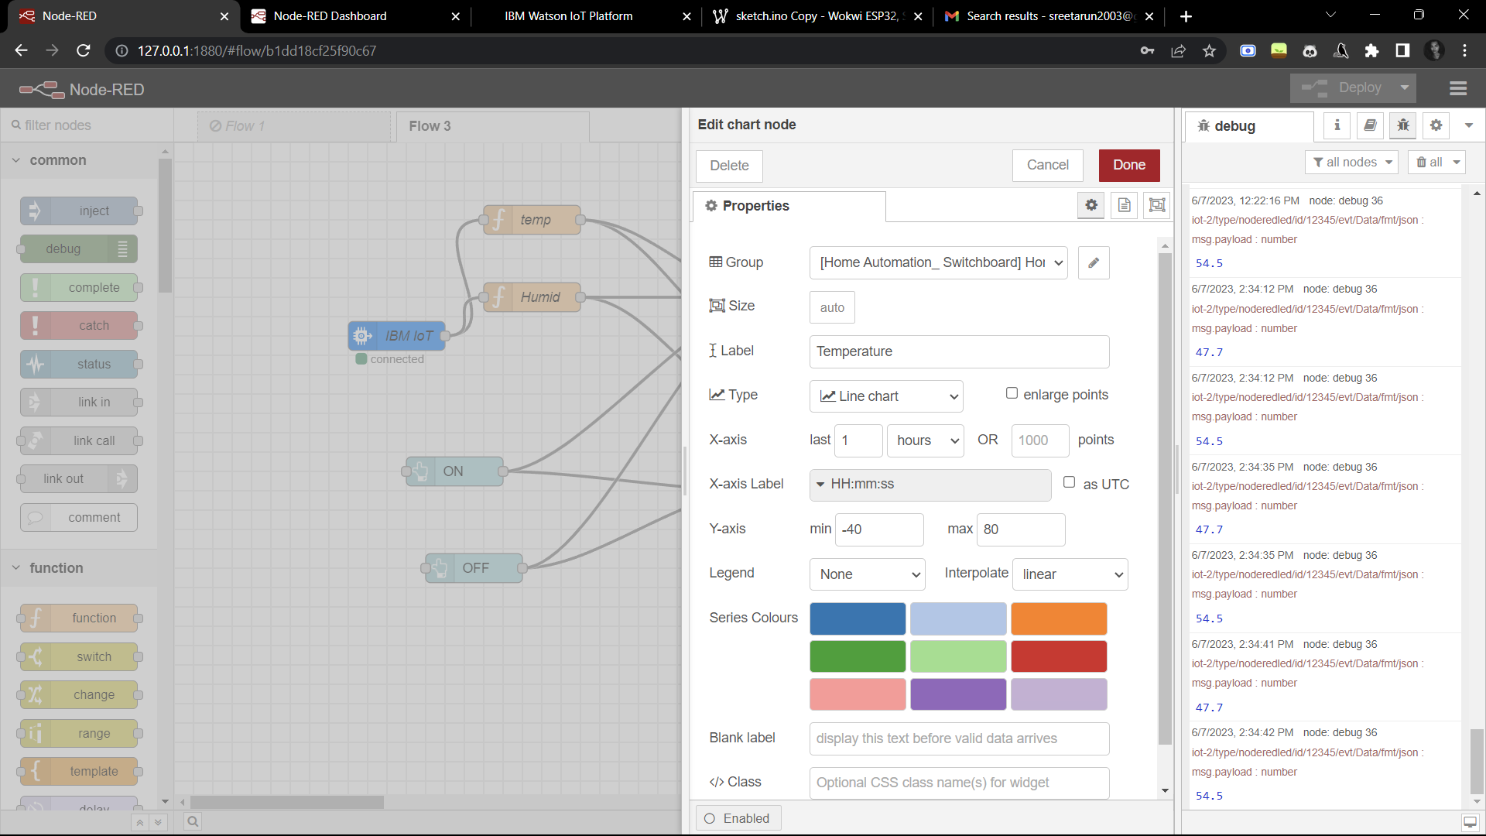

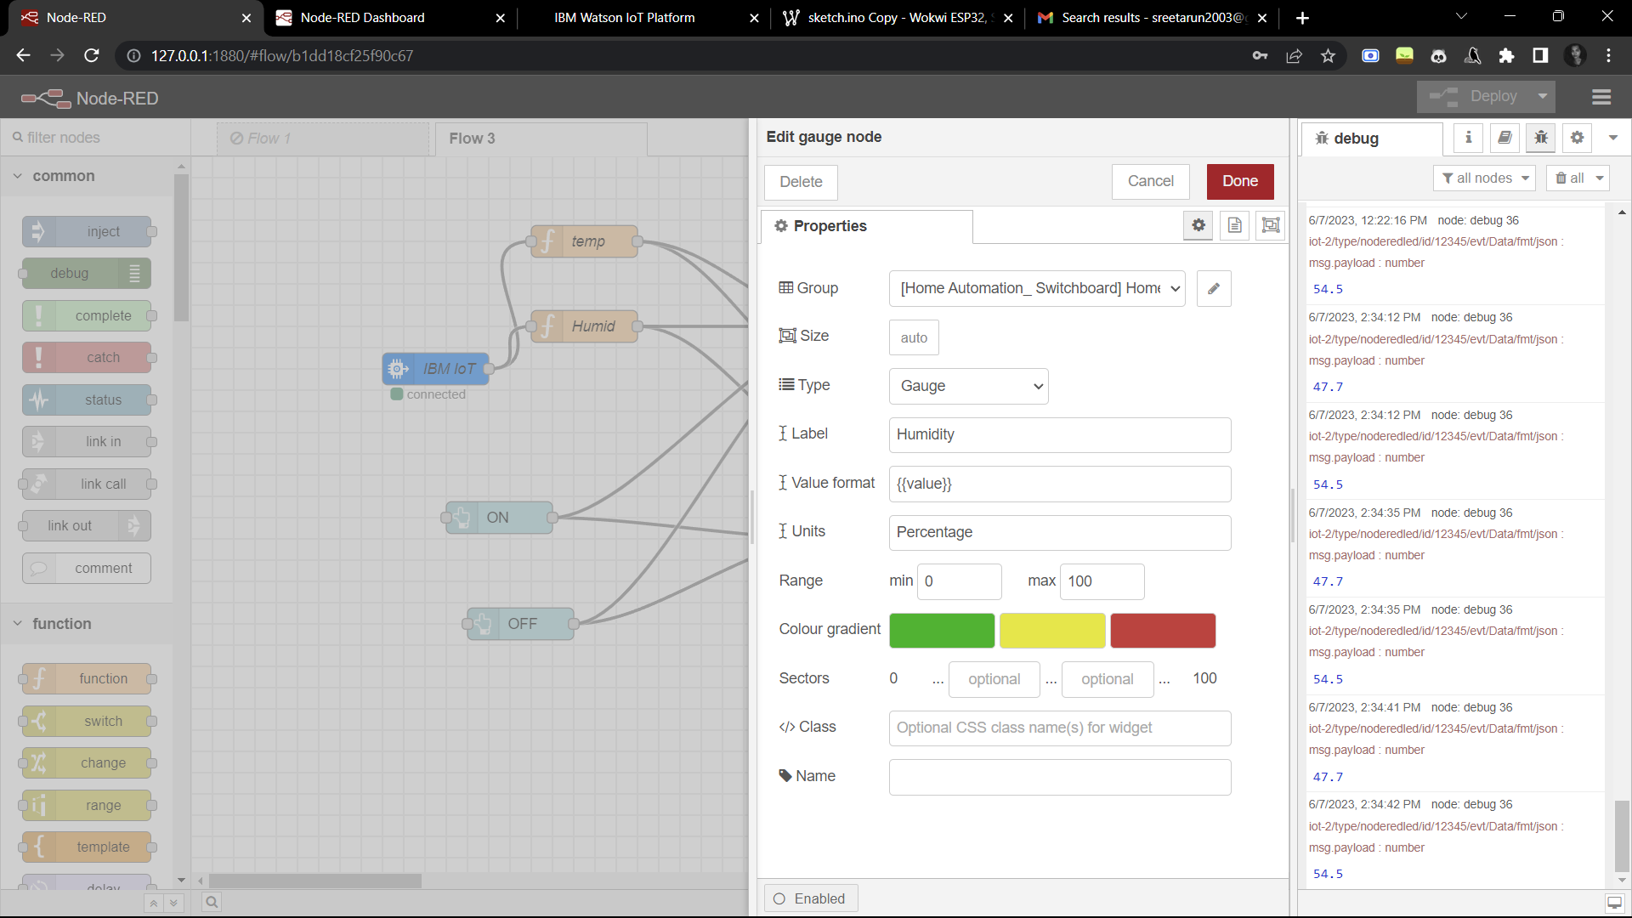

**Outputs:**

**LIGHT ON**

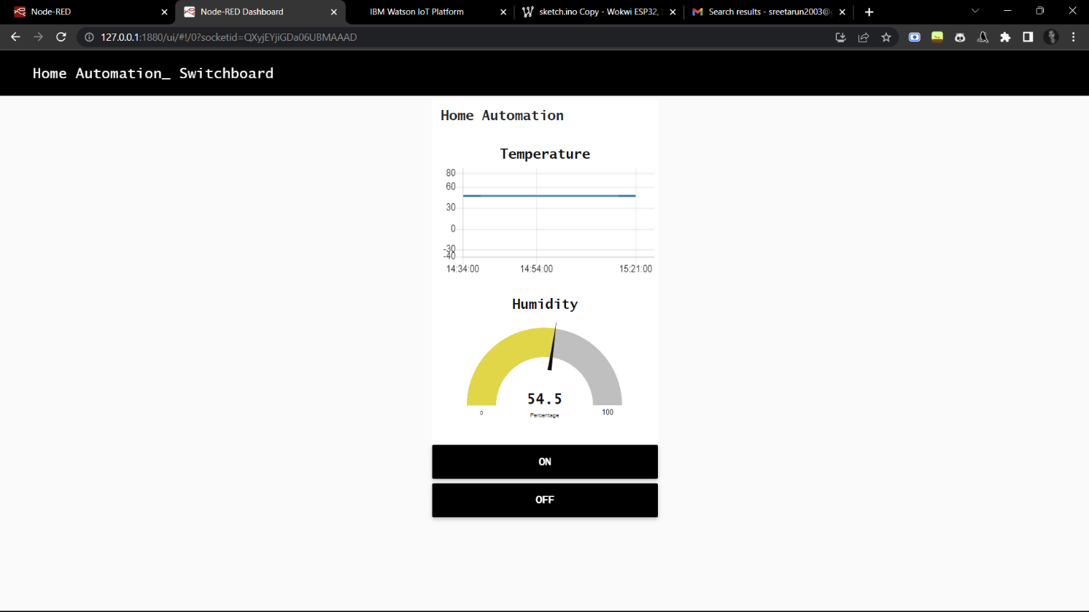 **Node Red Dashboard:**

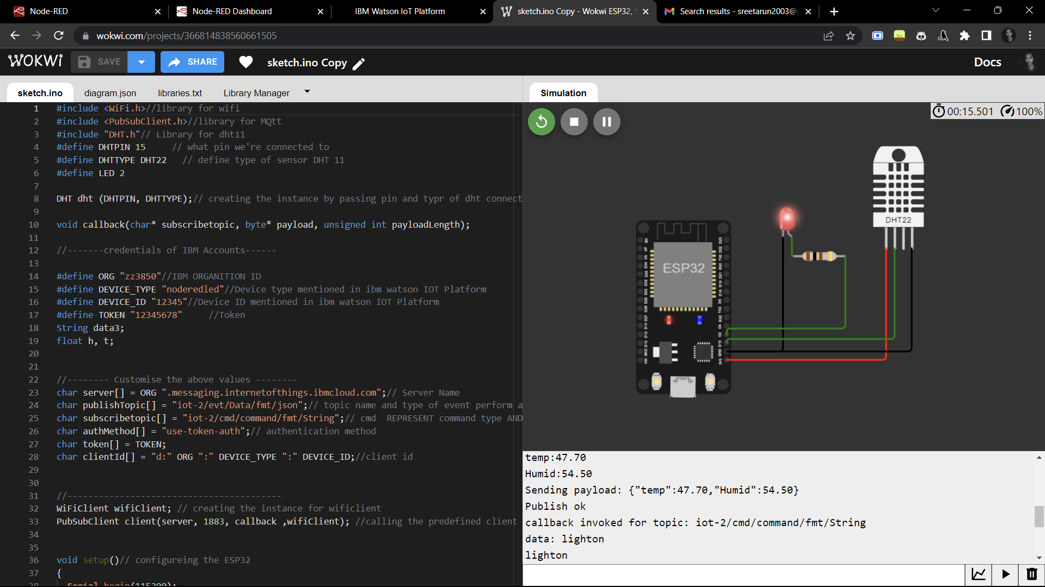**WOKWI:**

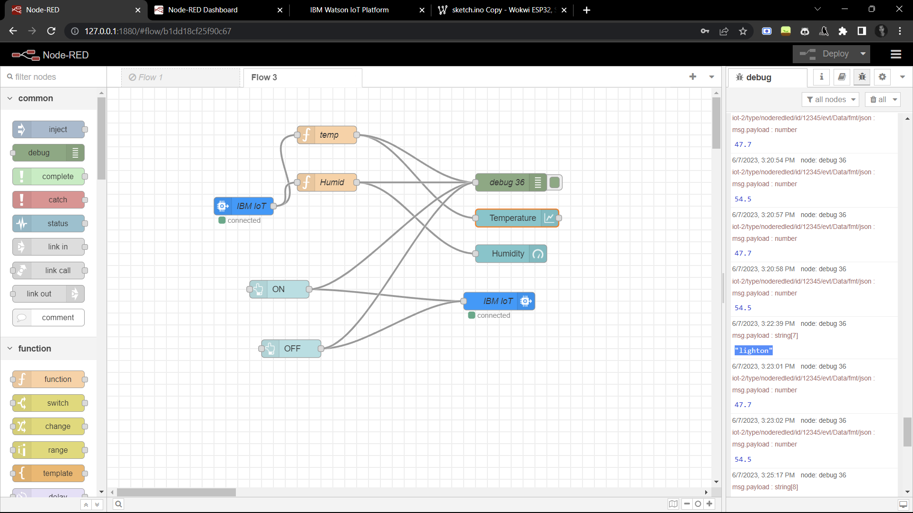**Node Red Debug:**

**LIGHT OFF**

**Node Red Dashboard:**

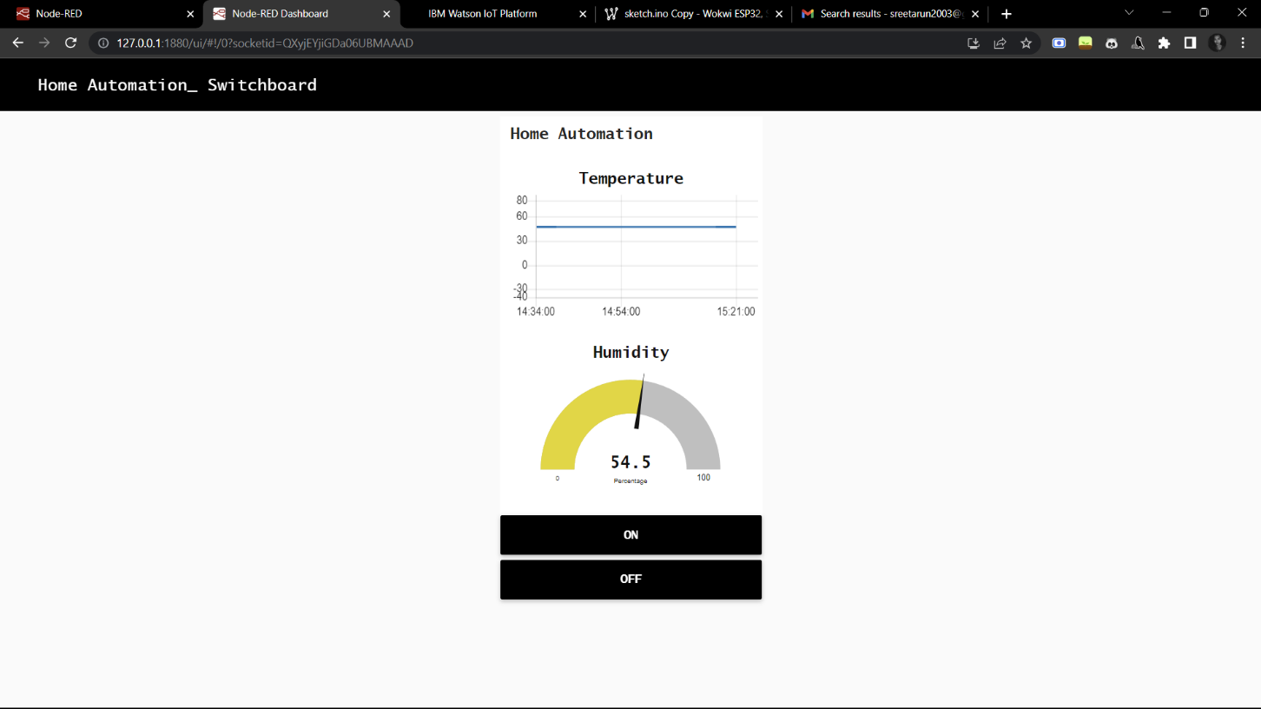

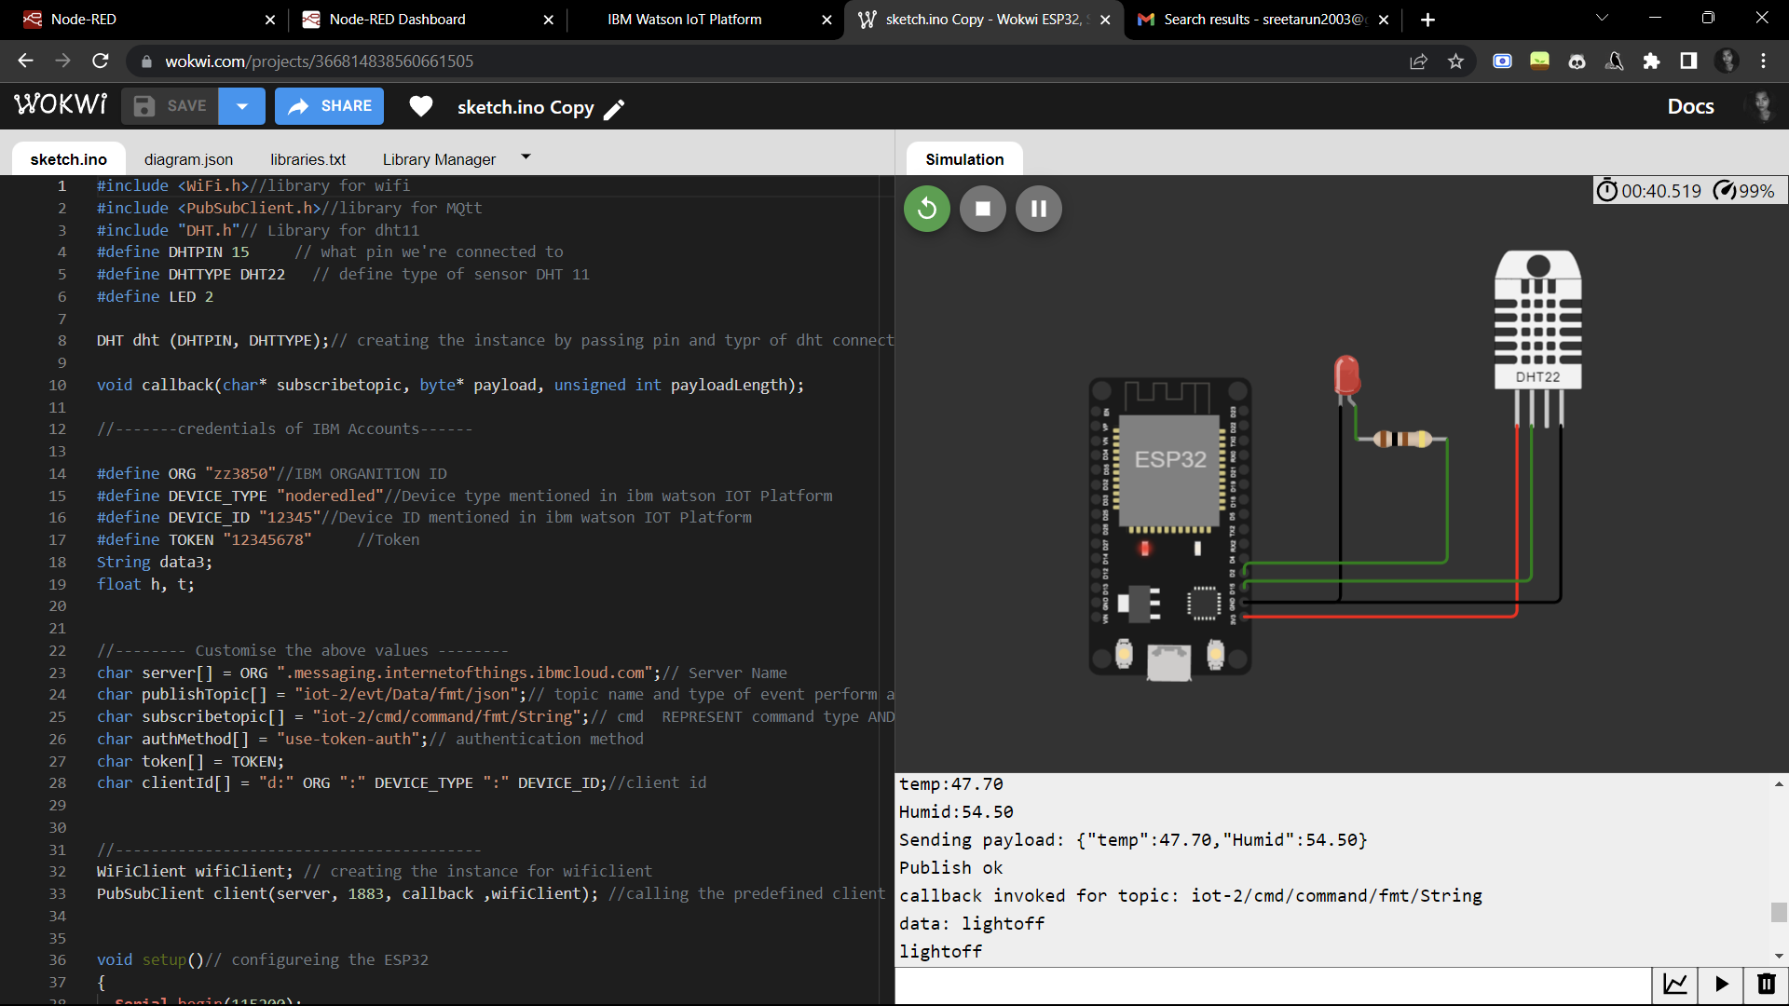**WOKWI:**

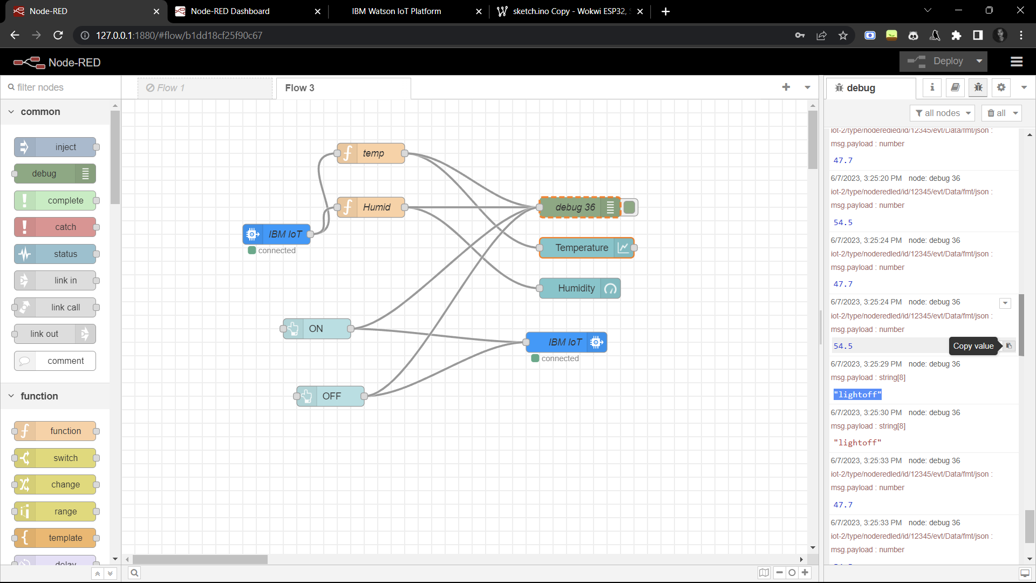**Node Red Debug:**

**Temperature and Humidity Monitoring**

**IBM Watson IOT:**

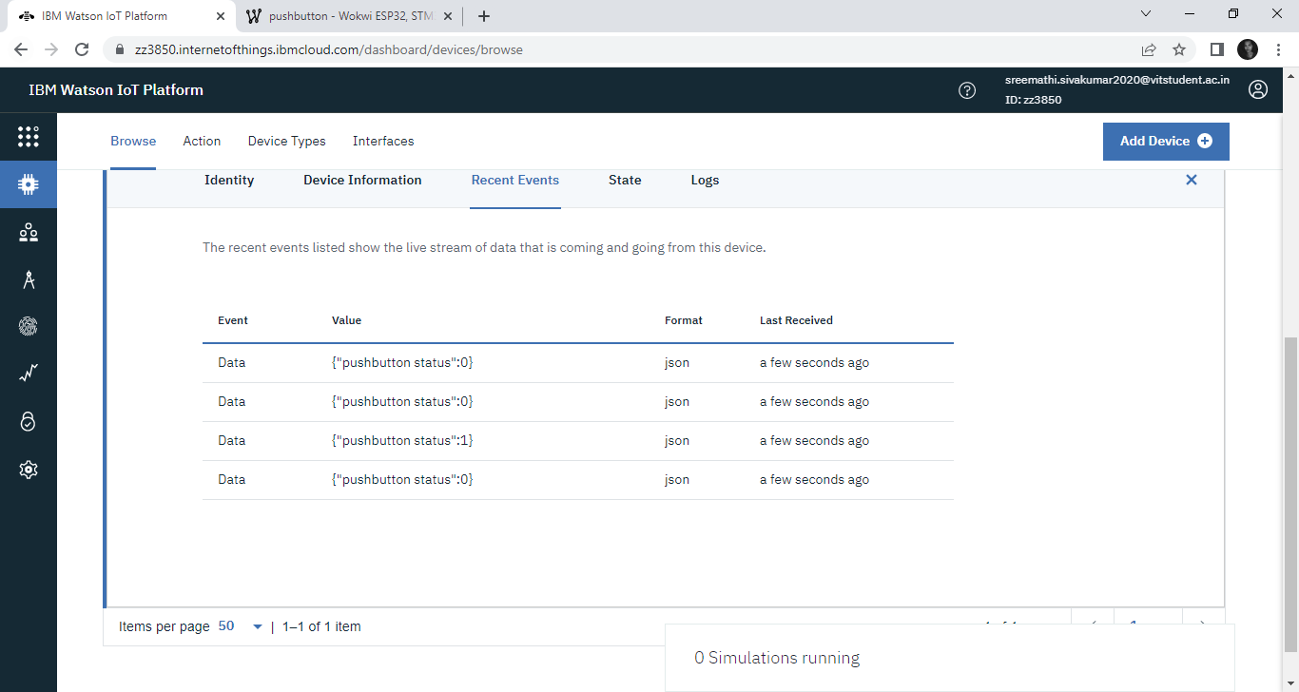

**Node Red Debug:**

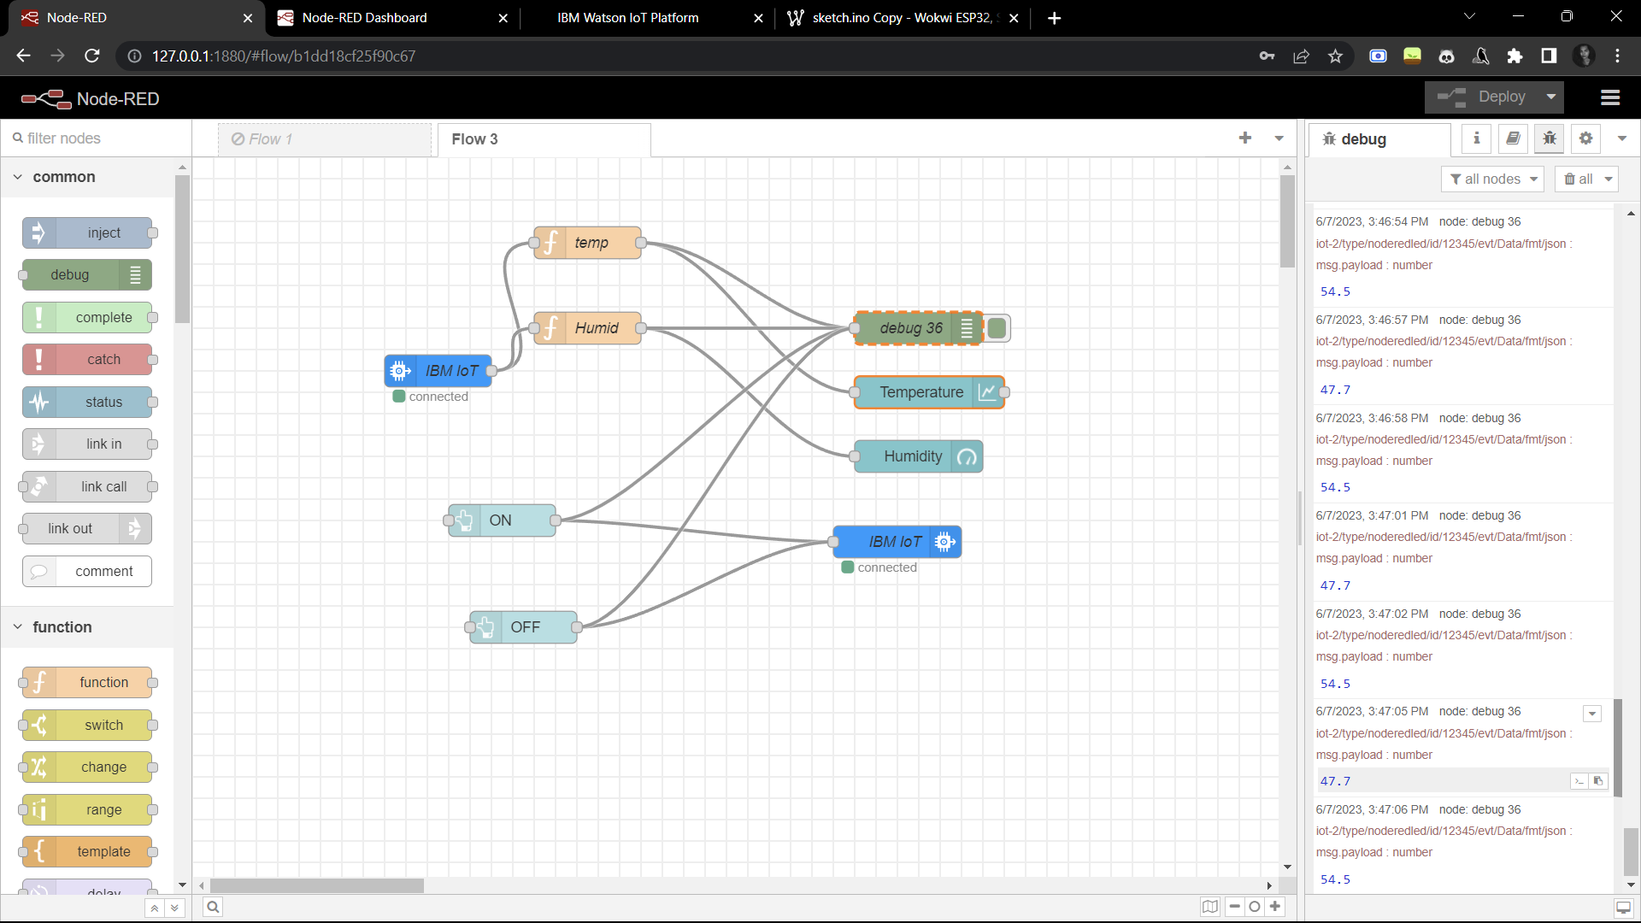

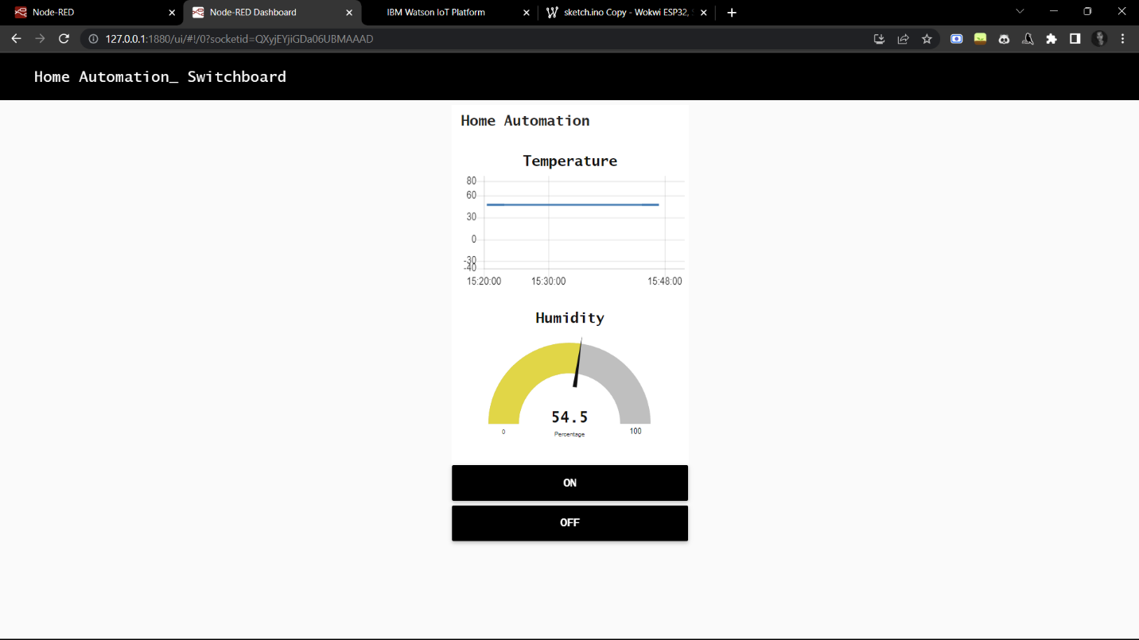**Node Red Dashboard:**

**Result:**

Thus, the temperature and humidity values from WOKWI has been uploaded to IBM Watson Iot using wifi module of ESP32 successfully and is visualized in the Node Red Dashboard. The LED of the circuit is switched ON and OFF using the buttons in the dashboard and IBMiot out Node and is successfully verified.